HOMEWORK 2

Student ID: P76087099 Name: Nguyen Vu Le Minh

**Description of your circuit:**

(Please describe the function and dataflow of the circuit.)

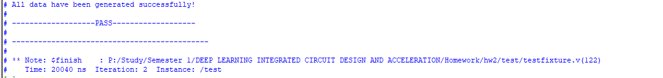

1. Description Function

**The average** is simply the sum of the numbers in a given problem, divided by the number of numbers added together. For example, if four number are added together their sum is divided by four to find the average or arithmetic mean.

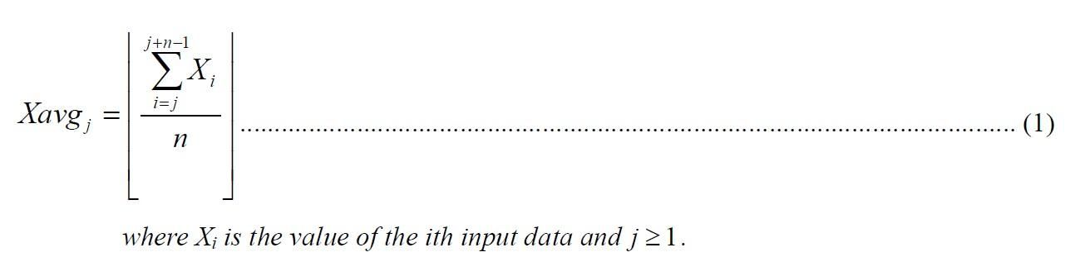

**The approximate average** is the one which is one of the last n input data whose value is smaller than and closest to the integral part of the real average.

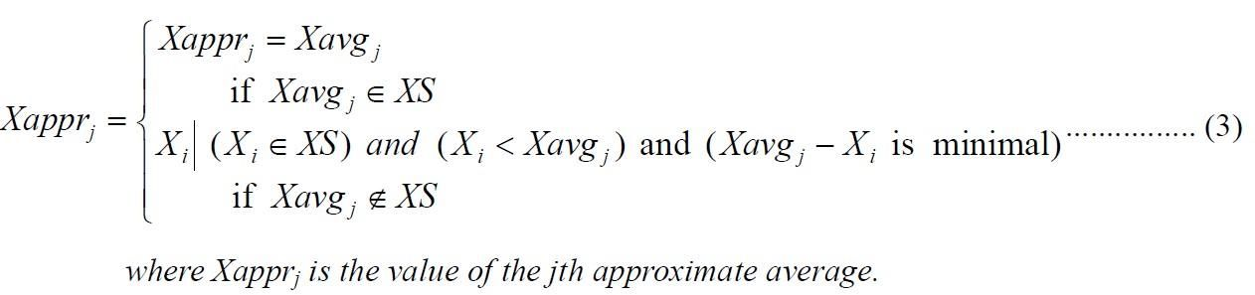

**The output** will be created by formula:

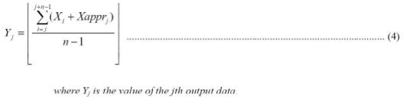

1. Description dataflow of the circuit

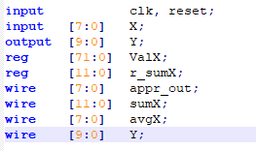

**Step1:**

This step, we have 2 register that are ValX and r_sumX. The ValX contain input values of X and the bits-size of ValX is 72 bit corresponding to 9 values of X. The r_sum is a register to remember the sum of the X values.

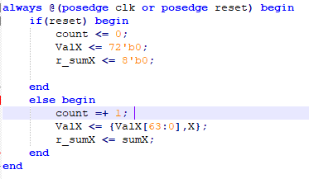

The computational system is reset by asserting reset signal for 2 periods. And The registers will save data at the positive edges of the clock.

**Step2:**



At this step, we begin to calculate sum and average of the X values.

**Step3:**

We add more a function is Calculation which responsible for calculating the value is not only smaller than the average value but also close to the average value. That is value approximate average.

**Step4:**

When we have the approximate average value, we calculate the output value by the following formula:



Its meaning is to take the approximate average value multiplied by 9. Then, add it with the value Sum. Eventually, we take the result divided by 8 to be Y. That is the expect output value.

**Lesson learn**

(Please write down the experience of completing this assignment, what you learned, and the points of difficulty.)

When I finish this homework, I learned a lot of knowledge about how to control the register value when the clock is change, how to reset all values when is reset is high.

Beside that I learned how to find the approximate average value by using other statements in my code such as if-else, for and case.